The Sustainable Reinvention of the Internal Combustion Engine: Fuel Decarbonization and Hybrid Systems
This article contests the idea that the internal combustion engine (ICE) is outdated, asserting its continued necessity for attaining global net-zero emissions, particularly in difficult-to-decarbonize transportation sectors and for the large current vehicle fleet. The ICE's long-term success depends on two things that work well together: using carbon-neutral fuels and developing advanced hybrid electric systems. "Drop-in" solutions like advanced biofuels and synthetic e-fuels are used as well. These solutions use existing infrastructure and provide high Well-to-Wheel CO2 reductions. Concurrently, hybridization (HEVs and PHEVs) maximizes engine efficiency by restricting ICE operation to its optimal region and employing regenerative braking. This strategy transforms the ICE into a technologically advanced platform that complements battery electric vehicles (BEVs), thus ensuring a practical path toward sustainable mobility.
Introduction
For decades the internal combustion engine (ICE) has been the leading power in global transportation, having unrivaled energy density, reliability and infrastructural maturity. However severe environmental concerns, climate change and reduction in the use of fossil fuels have brought the ICE to a turning point. Concurrently, the rising production of Battery electric vehicles (BEVs) could imply a complete replacement, while a more rational analysis tells us that the extinction of the ICE is neither feasible nor globally optimal. Instead, the future of the ICE is its reinvention. The reinvention of the ICE should be based on two main components: the use of sustainable fuel alternatives and the incorporation of an advanced hybrid system. This approach will allow the ICE to shift from being a liability to the climate to a pillar in a more diverse carbon neutral portfolio, especially in applications where full electric systems cannot be used.
The Resilience and Rationale for Continued ICE Use
While regulatory timelines have been placed, the majority of the world’s commercial vehicle fleet continues to operate using non-sustainable liquid fuels (petrol & diesel). For industries where reliability is required (e.g., Heavy Duty Trucking, Marine Transport & Aviation), the lengthy recharging period and weight of current battery technologies limit their use. Furthermore, the dependability and durability of ICEs means that when sold today, they will remain in operation on the road for decades to come.
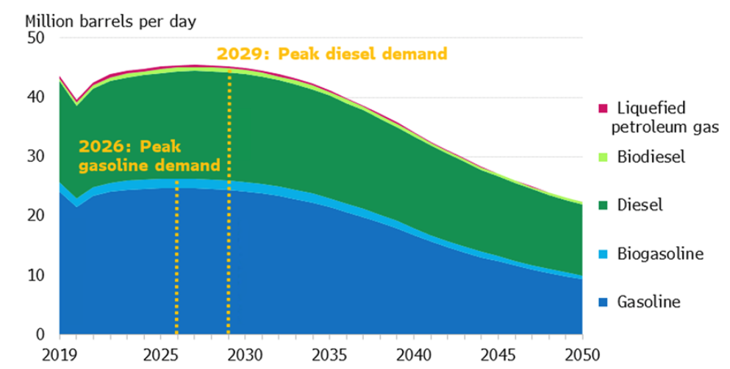
A strong focus on sales of battery electric vehicles ignores the current, very large and real ongoing gas emissions associated with the operation of vehicles powered by ICEs. Therefore, if we are to make any meaningful progress toward reducing greenhouse gas emissions, we must first evaluate how we produce the energy that fuels these vehicles. The issue at hand, however, is not the engine; it is the carbon emissions produced by the fuel used in the engine.
Pillar I: Decarbonizing the Energy Source
An alternative fuel approach to emissions reduction revolves around the idea of using renewable and low-carbon alternatives to replace petroleum-based fuels, a method which includes the current infrastructure for fuel distribution and refueling. As a result, this method provides a faster and impartial transition to climate neutrality in the entire population of vehicles.
Biofuels and Renewable Diesel
The advantages of the first- and second-generation types of biofuels from sustainable sources will lead to reductions in CO2, produced in the same manner as fossil fuel production. Other types of products include bioethanol (biodiesel) that is blended with gasoline (25%) and HVO (renewable diesel) that can directly be used in many types of engines for diesel. This could lead to reductions of well-to-wheel CO2 emissions up to 90% compared to diesel. Even though there are some limitations to the use of first generation biofuels due to competition for resources, the potential for large scale decarbonization through second generation technology offers a great opportunity for upcoming large scale applications of renewable fuels.
Synthetic E-Fuels (Power-to-Liquids)
Synthetic fuels, or e-fuels, made through the power-to-liquid process are the long-term solution. This process produces green hydrogen by electrolysis using renewable energy sources like solar and wind. Hydrocarbon chains are then created when the hydrogen combines with the CO2 that has been collected. The CO2 released from the air or a collected source makes the final fuel theoretically neutral. Because they are chemically equivalent to fossil fuels, e-fuels are 100% compatible with high-performance internal combustion engines (ICEs), offering a means of decarbonization without the need for mechanical replacement.

Hydrogen Combustion Engines (H2-ICE)
Hydrogen combustion is distinct in that it generates almost no tailpipe emissions—only water vapor—by using an ICE adapted for hydrogen. However, hydrogen fuel cells are expensive and complicated. H2-ICEs simplify the production process and lower conversion costs for delivering commercial vehicle platforms by utilizing the current engine block technology. With virtually no CO2 emissions in direct injection and combustion management, have produced thermal efficiency comparable to those of diesel engines. The construction of infrastructure for refueling and the large-scale production of green hydrogen are the primary obstacles to establishing a green hydrogen supply chain.
Pillar II: The Efficiency Revolution through Hybridization
The engine's inefficiency is addressed by hybridization, which alters the ICE's operating profile, while sustainable fuels address the carbon input. The engine is combined with an electric motor, energy storage (a battery), and advanced power electronics in hybrid electric vehicles (HEVs) and plug-in hybrid electric vehicles (PHEVs).
Optimal ICE Operation
The hybrid systems sustainability gain is in its ability to operate the ICE at its most efficient performance region. Traditional engines spend significant time operating inefficiently, this is due to wide speed and load range. Opposingly, in a hybrid the electric motor handles the low-speed maneuvers starting, and acceleration, allowing the ICE to run at a consistent, high-efficiency point close to its maximum thermal efficiency.

System Architectures and Energy Recovery
Hybrid systems are categorized into ser, parallel, and power split architectures.
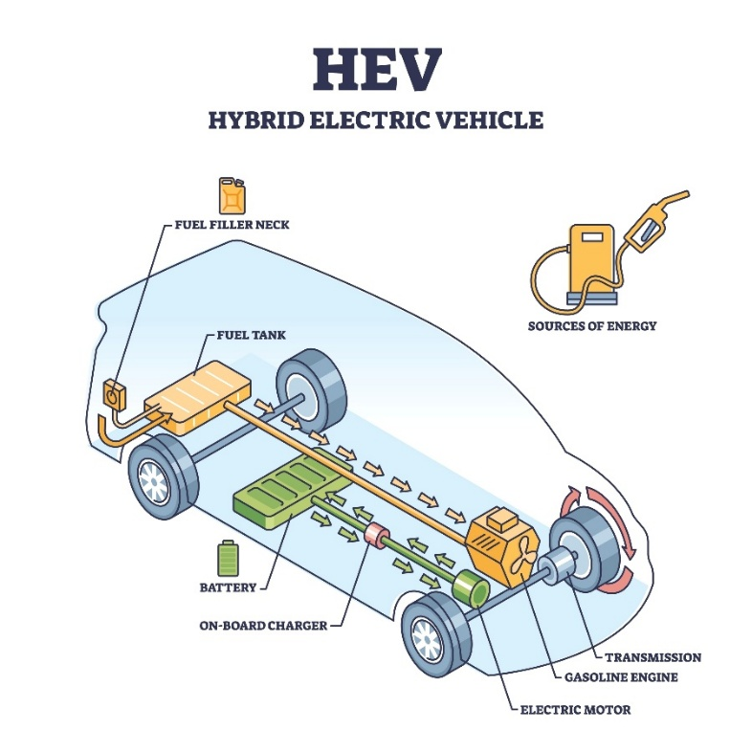
Effective systems such as the power-split configuration use planetary gear sets to distribute power among the wheels, the generator, and the engine through regenerative breaking. This happens by recovering Kinetic energy that would be lost as heat and storing it as electrical energy in the battery for later use.
Conclusion
There is no one solution to the future of sustainability with the use of the ICE, although electric vehicles are the best solution for urban transportation the likelihood of it replacing the ICE is very low. Combining the hybrid ICE technology powered by carbon neutral fuel (Including biofuels and synthetic e-fuels) and pure electric vehicles will be the most practical way to decarbonize the current fleet of vehicles while also retaining critical heavy duty, aviation and marine functions. This way we transition towards achieving our goal of global net-zero emissions.

References
European Commission (2023) Alternative Fuels Infrastructure Regulation (AFIR): A Guide to Implementation.
Rolls-Royce Power Systems (2023) A sustainable future for combustion engines: The role of HVO.
SAE International (2024) The Role of Sustainable Fuels in Decarbonizing Mobility.
Simcenter (2024) What will be the fuel of the future for Internal Combustion Engines? Siemens Digital Industries Software.
Wang, Z. et al. (2022) 'Comparative study on the thermal efficiency and emission performance of hydrogen-fueled internal combustion engines', Journal of Cleaner Production.

